IFT 266 Introduction to Network Information Communication Technology (ICT)
Lab 3
Packet Tracer - Physical Workspace

After you complete each step, put a ‘√’ or ‘x’ in the completed box
Note: This lab can be a little temperamental at times so do not over stress if it does not work exactly as per the steps.

- Packet Tracer not only logically simulates the required environment but also simulates devices physically too.
- In previous lab sessions, you have used the logical workspace to create topologies. The physical workspace makes your logical topology more realistic by giving it a physical dimension.

- The physical workspace has four environments: Intercity, City, Building, and Wiring closet.

- Intercity: This is the largest environment consisting of cities. Cities, buildings, and wiring closets can be created in this layer using the controls on the toolbar.
- Cities: This layer contains buildings and wiring closets. The default city is named Home City. Cities can be dragged and placed anywhere on the intercity map.
- Buildings: This layer contains wiring closets. The default building is named Corporate Office.
- Wiring closet: This is the final layer that contains devices placed in the logical topology. Its default name is Main Wiring Closet and it doesn't have any specified area.

- All devices used in the logical workspace are placed in Main Wiring Closet; we'll learn how to move them. Create a topology in the logical workspace with two PCs. Replace their default modules with PT-HOST-NM-1FGE (remember to switch off both the PCs before doing this) because Ethernet has distance restrictions.

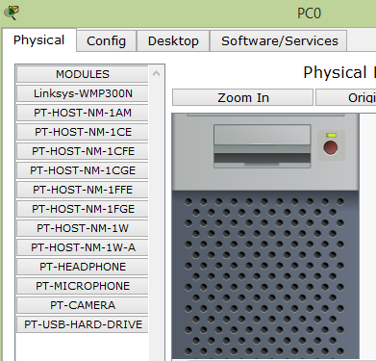
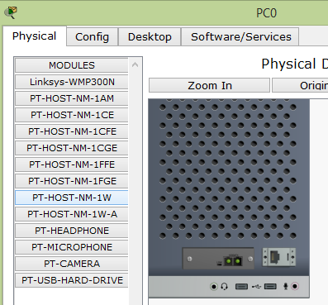

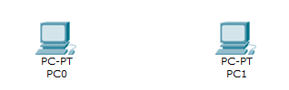



- Connect both PCs with a fiber cable and assign IP addresses.
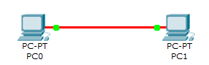

- Switch to the physical view, click on the New City button on the yellow toolbar, and rename the newly-created city. In this example, we'll name it Remote City. Open this city and create a new building, and then create a new wiring closet within this building.

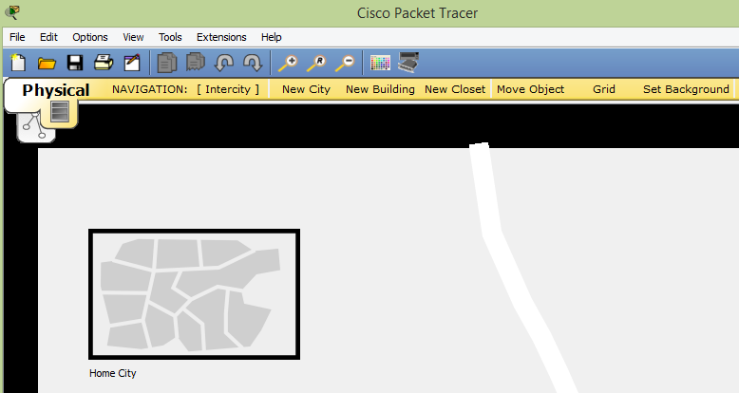
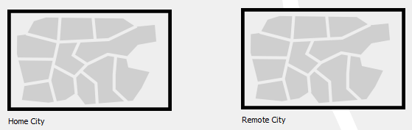
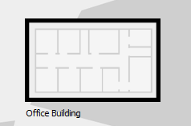

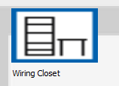

- Use the NAVIGATION button and navigate to Home City | Corporate Office | Main Wiring Closet. This contains both the PCs we inserted in the logical workspace, as shown in the following screenshot:

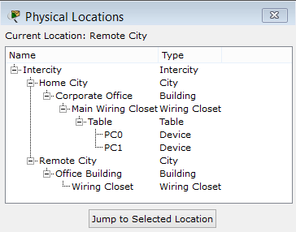

- Use the Move Object button (or keys Shift + M) and move one of the PCs to Remote City | Office Building | Wiring Closet, as shown in the following screenshot. This can also be done in the navigation box by using the drag-and-drop feature.

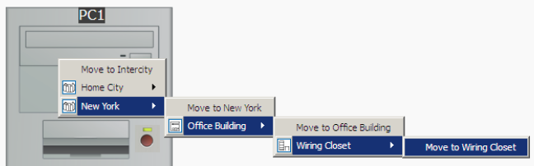

- Navigate to the intercity and you'll find a link between home city and remote city. Now navigate to Remote City | Office Building | Wiring Closet to find the PC we moved.
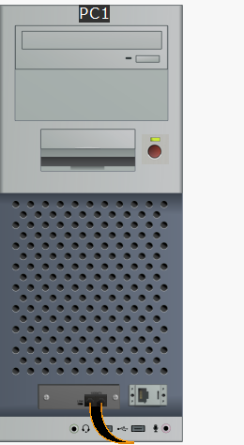

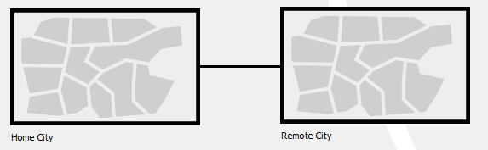

- Moving back to the logical topology, you'll see absolutely no difference in the placement of the PCs. Devices can also be moved to the intercity, cities, and buildings. In these cases, the icon of the device is displayed in the physical environment.

- The physical view adds a dimension of distance for wired and wireless devices. This is very useful for working out the placement of wireless devices.

- Measuring a cable is as easy as placing the pointer on a cable in the physical view
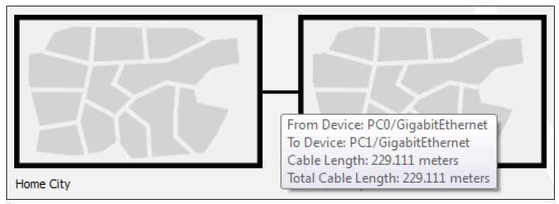

- Standard copper Ethernet cables can extend up to a length of 100 meters; let's test this with the physical view:
- Create the same two PC topologies that we used previously but use the copper cable instead of the fiber one.
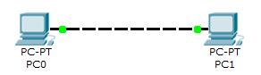

- In the physical view, move both the PCs to the intercity as we did previously.
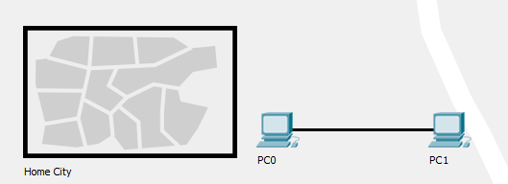

- Navigate to the intercity and check the distance between them. If the distance is less than 100 meters, move them further apart, until the distance between them is more than 100 meters.
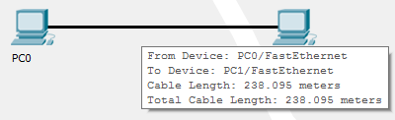

- Now come back to the logical view and you'll find that the link status of both the PCs is red because the connection came down due to the distance

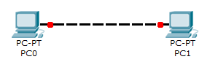

- Delete the link between the PCs and place a Repeater-PT from the hubs section. Connect both the PCs to the repeater with a copper straight-through cable. The link still remains down because this repeater was placed in the main wiring closet (which is still at a larger distance) that is very far from the intercity.
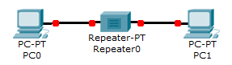

- Move to the physical view, navigate to the Main Wiring Closet and move the repeater to the intercity. Go to the intercity and place the hub between the two PCs. Now you'll find that the link comes up as the repeater boosts the signal.

